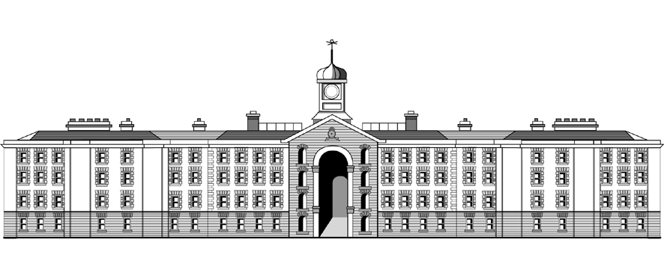

**Griffith College Limerick**

**COMPUTING LAB TITLE SHEET**

**Course:** B.Sc. in Computing (Level 7 and Level 8)

**Stage/Year:** II

**Module:** Object-Oriented Programming

**Semester:** I

**Lab Number:** I

**Date of Title Issue:** 26/09/23

**Assignment Deadline: 03/10/22 23:59**

**Assignment Submission:** Submitted on Moodle

**Assignment Weighting: 10%**

## Assignment Title

|  |  |
| --- | --- |
| **Create a project called LabOne_StudentNumber**  With StudentNumber being your student number i.e LabOne_32323  **Add your student name and id as a comment at the top of each file.**          **20% of marks are for comments and coding standards**   * Add a comment with your name and ID at the top of the files. * Use lowercase for variable names. * Use uppercase for class names. * Use the given names for attributes and methods. * Keep each class/interface in a separate .java file. * Keep all attributes private unless otherwise stated. * Comment any behaviours you added.  |  | | --- | | **Zip the whole project folder and upload your folder as**  **LabOne_StudentNumber.zip** | |
|  |